**Git reset Command**

1. To remove changes from staging area
2. To undo commits at repository level
3. To remove changes from staging area :-

In this we talk about the files between working directory and staging area.

$ git reset file.txt

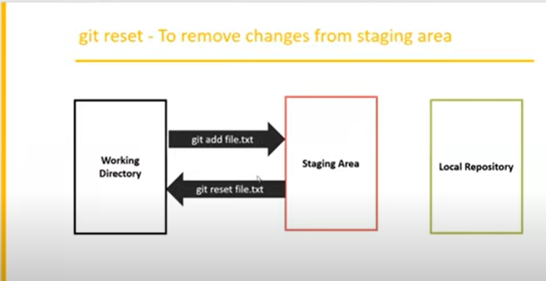

1. To undo commits at repository level :-

In this ,we talk about the commits between staging area and local repository.

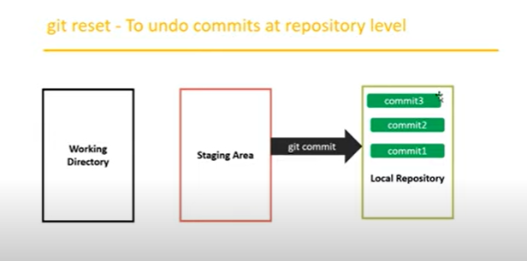

$ git reset <mode> <commit id>

Moves the HEAD to the specified commit, and all remaining recent commits will be removed.

Mode- mode will be decide whether these changes are going to remove from staging area and working directory or not.

Types of modes are :-

1. --mixed
2. --soft
3. –hard

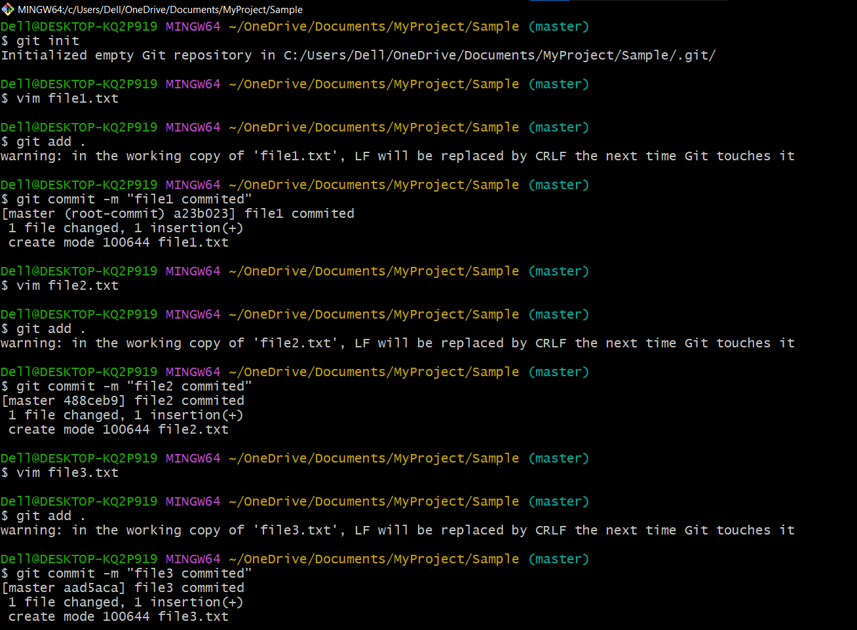First add some files in staging and working directory:-

1. **reset with –mixed Mode :-** 
   * + - 1. It is the default mode.
         2. To discard commits in the local repository and to discard changes in staging area.
         3. It will not touch working directory

To reset with --mixed mode:-

$ git reset --mixed 488ceb9

(where 488ceb9 is commit id of the previous commit )

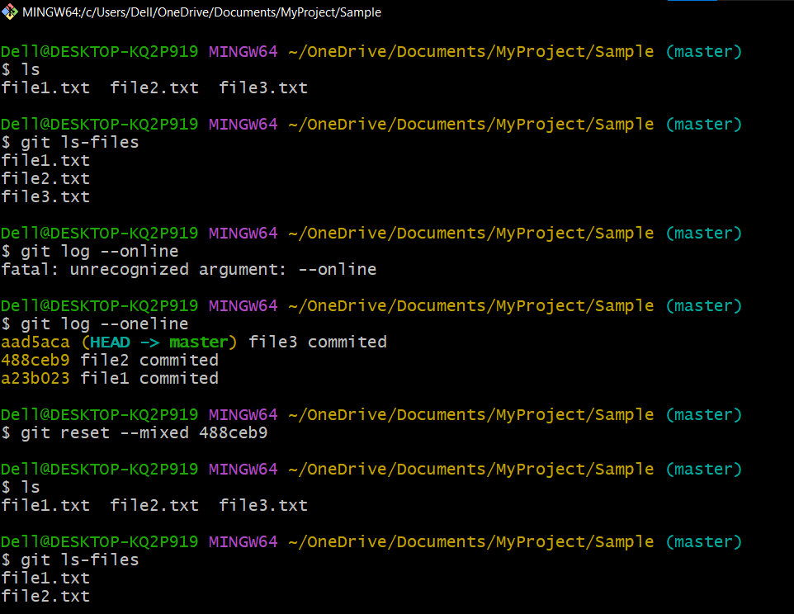

1. reset with –soft Mode:-
2. It is exactly same as - -mixed option, but changes are available in working directory as well as staging area means only commits are reset.
3. It won’t touch staging area and working directory.
4. As changes already present in staging area, just have to use commit revert back.

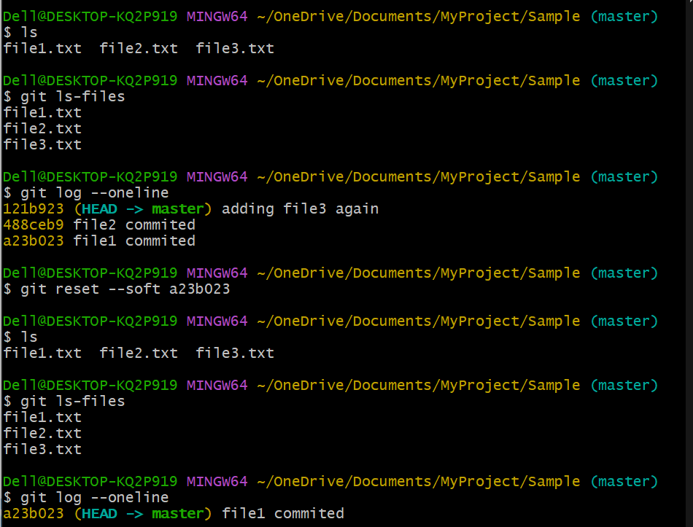

1. reset with --hard mode :-

It is same as - -mixed except that changes will be removed from everywhere (local repository ,staging area and working directory)

It is impossible to revert back and hence while using hard reset we have to special care.

